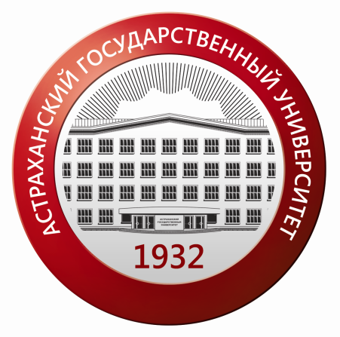
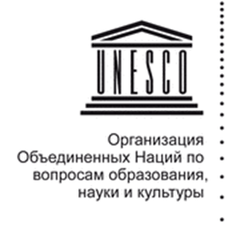

THE MINISTRY OF EDUCATION AND SCIENCE
OF THE RUSSIAN FEDERATION
Astrakhan State University
UNESCO Chair
Administration of the Astrakhan Region
Astrakhan Commercial and Industrial Chamber

Dear colleagues,
Astrakhan State University would like to invite you to participate in the
INTERANTIONAL CONGRESS
“ELITES AND LEADERS: FORMATION STRATEGIES IN A MODERN UNIVERSTY”
April 19-22, 2017

The aim of the Congress is to discuss the most urgent issues connected with the notions of elites and leadership, their roles in a knowledge society, the requirements that are made to these notions in a modern world, as well as the issues connected with the elite education.
Suggested topics for discussion:
- Modern elite and mass education: pro et contra
- Elite, leaders and team work in modern companies
- Culture of elites and leadership
- Philosophy of elite and leadership in information society
- Sociological image of modern elite and modern leader
- Professional elites and political issues
- Elite selection and University mission
- Open education: leadership and innovations
- Russian cultural elite: history and the present
- Project-based learning: best projects and international practices (CDIO initiative) of staff and students development
Sessions:
- Social and cultural aspects of elite and leadership phenomenon.
- Educational elitology: theories and university practices.
- Cognitive sciences and elite education.
- Technology formation of elite consciousness: modern education in a context of lean production and “six sigma”.
- Information technology in elite and leadership formation.
- “Critical thinking and writing” as a tool of elite consciousness formation.
- Modern communication strategies and leadership.
Presentation of the encyclopedical dictionary: “Russian cultural elite of the 20th century”
The following workshops will be held on April 21-22, 2017 within the Congress:
“Writing and thinking” (practices of Bard college, St. Petersburg University, ASU)
“Leadership, soft-skills, team-work in the process of education”
“Organizational learning as a tool of elite and leadership formation”, etc. The certificates of participation (advanced training) will be issued upon the completion.

Organizing committee of the Congress
Chairman of the organizing committee:
Doctor of Economics, Professor, acting rector A.P. Lunev (Astrakhan)
Co-chairman of the organizing committee:
Doctor of Pedagogic Sciences, Professor, A.M. Treschev (Astrakhan); Doctor of Philosophical Sciences, Professor, P.L. Karabuschenko (Astrakhan)
Members of the organizing committee of the International Elitological Congress:
Doctor of Political Sciences, Professor, А.А. Vartumyan (Pyatigorsk); Doctor of Philosophical Sciences, Professor, L.V. Baeva (Astrakhan); Doctor of Political Sciences, Professor, А.V. Ponedelkov (Rostov-on-Don); Doctor of Philosophical Sciences, Professor, A.P. Romanova (Astrakhan); Doctor of Philosophical Sciences, Professor, G.V. Sorina (Moscow); Doctor of Political Sciences, М.М. Fedorova (Мoscow); Doctor of Philosophical Sciences, B.А. Bicheev (Elista) , Doctor of Philosophical Sciences, Professor, S.B.Тokareva (Volgograd), Professor. Jh. Van der Bergh (South Africa), ambassador plenipotentiary Aniset Gabriel Kochofa (Benin)
Working languages are Russian and English.
All application forms and manuscripts for participation in the Congress should be sent before March 15, 2017 to the following e-mail address: elit.kong2017@gmail.com
Please feel free to contact us if you have any further questions or concerns: (8512)610816, 494148,610815.
Application form
Full name
Academic degree, academic title, position
Full name of the work place
Topic of the report and session
Home address (if you are a non-resident, please indicate your postal code)
Telephone (country code, city code, mobile phone, land-line phone)
E-mail
Form of participation (full-time/virtual)
Hotel reservation | - Yes. from _____ to ______ 2017.  - No.

Virtual participation is possible.
The organizing committee reserves the right to select the participants of the Congress on the basis of applications received.
Information on the manuscripts published within the Congress will be transferred to the RSCI system. Links to the proceedings in the RISC system, as well as the opportunity to their access in PDF format will be available in "Archive of publications"

Manuscript requirements

1. Microsoft Word for Windows is required for typing, formulas and tables. The text should be typeset in Microsoft Word (MS Word) using the standard Times New Roman font, 12 pt, line spacing is 1.0. Margins from all sides are 2 cm. Indent is 0.5 cm; page orientation is portrait (vertical); the manuscript should contain 3-5 pages. All figures and tables should be numbered consecutively and provided with names or captions.
2. Title. Use uppercase, bold letters and center alignment for the TITLE;
then on the next line indicate FULL NAME of the author using bold italic and right alignment;
next line should contain academic degree, academic title, university name, city or position, affiliation, city using italic font and right alignment (abbreviations are not allowed);
3. Use one sentence interval to arrange the text of the manuscript.
4. Use one sentence interval to indicate “References”. Arrange all references alphabetically and in compliance with GOST Р 7.0.5 – 2008. References in the text should be indicated in the following way: [1, p. 277]. Automatic paged links are not allowed.
The registration fee for participation in the International Congress is 1000 rubles.
The registration fee for students and postgraduate students participating in a student section is 250 rubles.

Bank details:
FSBEI “Astrakhan State University”
Receiver: TIN 3016009269 CRR 301601001
Federal Treasury Department for the Astrakhan Region (Astrakhan State University/ personal account 20256Ц14780)
Current account 40501810400002000002
Bank: Public Clearing Centre of Main Directorate of the Bank of Russia of the Astrakhan Region, Astrakhan
BIC code 041203001
BCC 00000000000000000130
Payment details: payment for the Congress Proceedings publishing “ELITES AND LEADERS: FORMATION STRATEGIES IN A MODERN UNIVERSITY”.
Postal address: 414056, 20a Tatischev Str., Astrakhan State University. Organizing Committee: elit.kong2017@gmail.com
Online registration is possible: http:// congress2017.asu.edu.ru

